

Leanna Walker

Practices for Secure Software Report

Table of Contents
Document Revision History 3
Client 3
Instructions 3
Developer 4
1. Algorithm Cipher 4
2. Certificate Generation 4
3. Deploy Cipher 4
4. Secure Communications 4
5. Secondary Testing 4
6. Functional Testing 4
7. Summary 4
8. Industry Standard Best Practices 4

Document Revision History

Version | Date | Author | Comments
1.0 | December 12, 2025 | Leanna Walker

Client



Instructions

Submit this completed practices for secure software report. Replace the bracketed text with the relevant information. You must document your process for writing secure communications and refactoring code that complies with software security testing protocols.

- Respond to the steps outlined below and include your findings.
- Respond using your own words. You may also choose to include images or supporting materials. If you include them, make certain to insert them in all the relevant locations in the document.
- Refer to the Project Two Guidelines and Rubric for more detailed instructions about each section of the template.

Developer
Leanna Walker

Algorithm Cipher

Artemis Financial wants to add file verification to their website to improve security. To do this they need a checksum, and to make a good checksum it needs to be a hash function so that if a hacker tries to change files, the system can detect it by comparing checksums. My recommendation for an algorithm cipher for Artemis Financial is that they use SHA-256. It is the industry standard for checksums and it’s in the Bouncy Castle library that I explored in Project One.
SHA-256 is two hundred- and fifty-six-bits long hash value, which makes it extremely difficult and virtually impossible for a hacker to replicate or guess the correct value for the checksum. This is what we want for Artemis Financial, it’s another added level of security.
SHA-256 in in charge of verifying the files, but to actually send the files safely over the internet, the websites need a different kind of security. To do that, the website uses random number generators and symmetric or asymmetric encryption. Symmetric uses one shared key, while asymmetric uses one public key and one private key. So, if Artemis Financial uses random number generators that make unique keys, then every time a user gets on the internet and uses their website it will be secure.
Since technology is constantly changing with new advancements every day, older versions of algorithm ciphers have been figured out by hackers. So, it’s very important to keep coming up with more difficult ways of securing connections and files. SHA-256 is the standard today to make sure that the company’s security is modern and up to date.

Certificate Generation
Insert a screenshot below of the CER file.

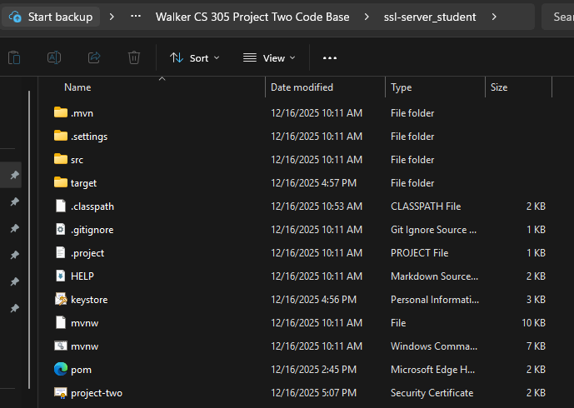
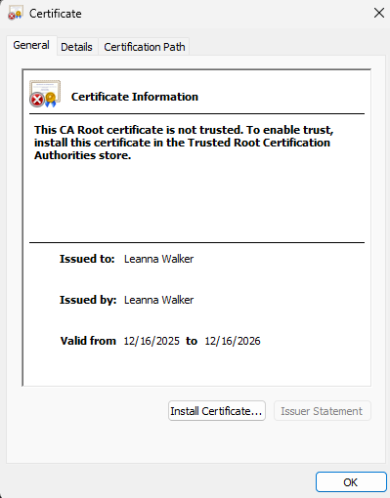

Deploy Cipher
Insert a screenshot below of the checksum verification.

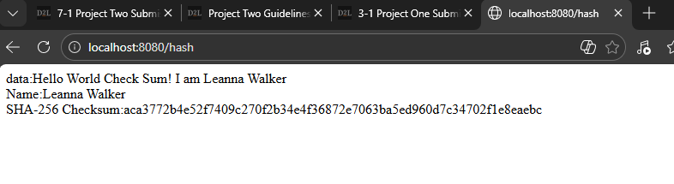

Secure Communications
Insert a screenshot below of the web browser that shows a secure webpage.

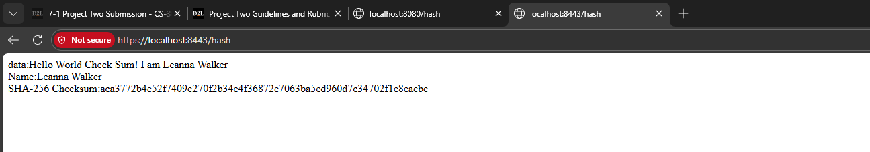

Secondary Testing
Insert screenshots below of the refactored code executed without errors and the dependency-check report.

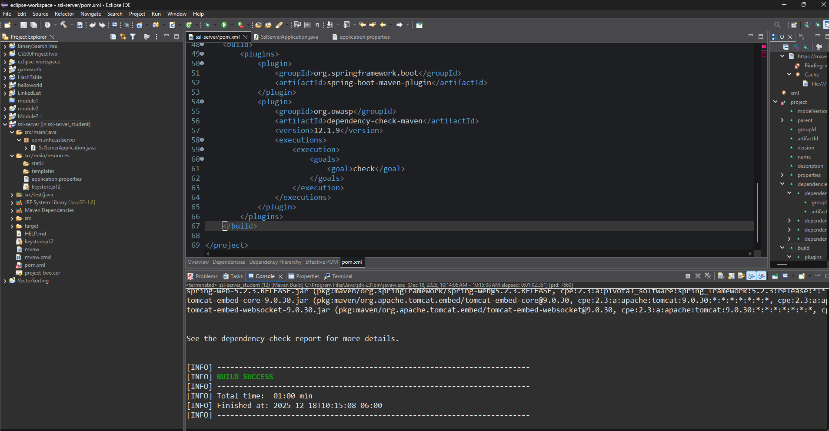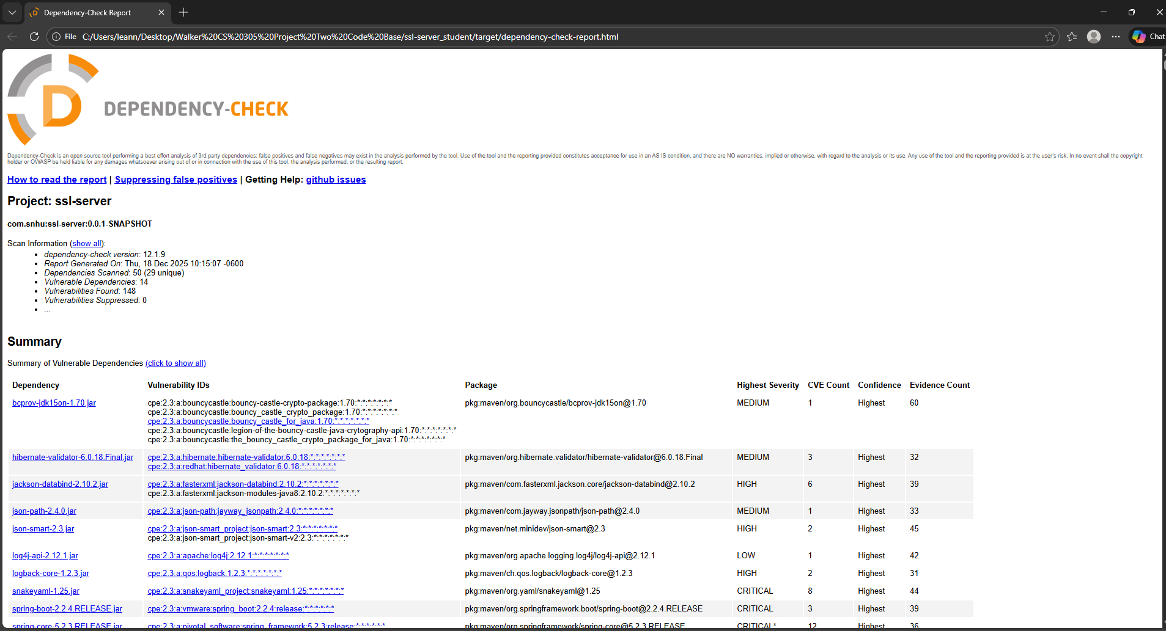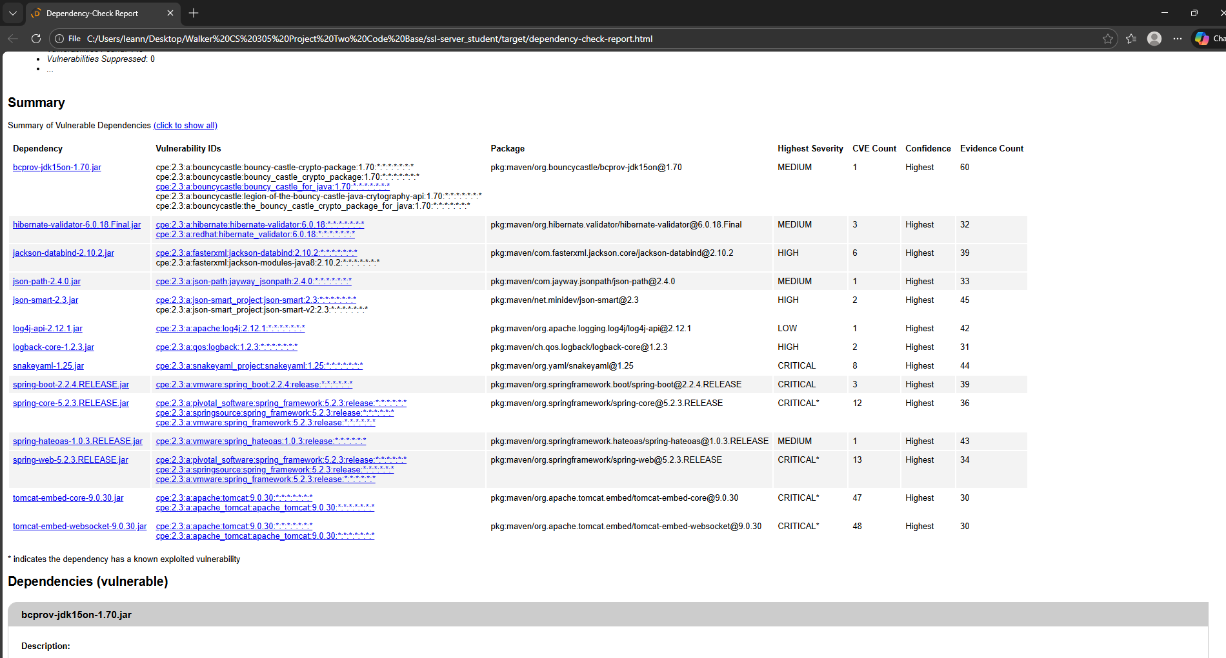

Functional Testing
Insert a screenshot below of the refactored code executed without errors.

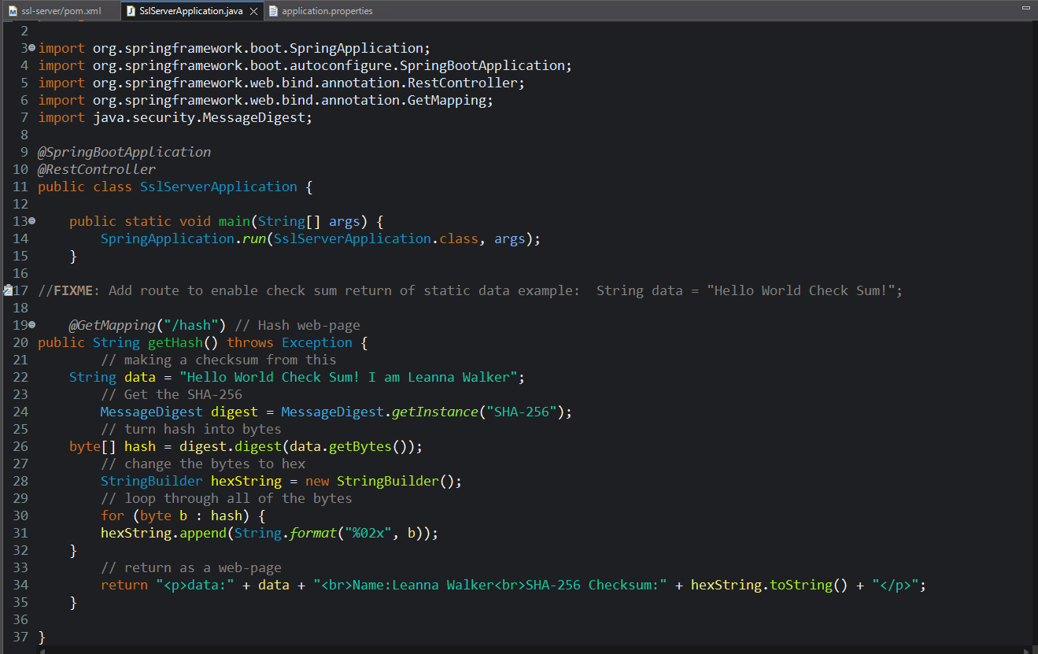

Summary

Artemis Financial needs a secure connection for communications for their website, and in order to do this I implemented two security features that address the area of security, that is Cryptography. The first is that I added a checksum verification with SHA-256. Which means I used the checksum to create a convoluted, unreadable unique ID number from the original data. This is the best way to protect the customers’ sensitive financial information, because if a hacker tries to change the data, the ID won’t match, and the system will know something is wrong.
The second Cryptography security feature I added is HTTPS, which makes sure that every time they login to Artemis Financial from their phone or computer that that connection is safe. It does this by encrypting the data during the connection so if someone gets it, they won’t be able to understand it, and this keeps the client’s information safe.
While the main area of security that I addressed was Crptography through the use of the checksum and HTTPS, I also made the Code Quality better by updating the Bouncy Castle library to a newer more secure version.
In order to have the most airtight security for Artemis Financial, I left it prudent to not only implement one security feature, but layer multiple so that it increases the odds we will be able to spot and prevent a security attack. First, I added a checksum for data verification. Then, I added HTTPS to encrypt the whole connection.

Industry Standard Best Practices

One way that I used best practices was checking to make sure that the software was updated. So, when parts were out of date and less secure like with the Bouncy Castle library, I then updated it to a newer more secure version. Another way that I followed best practices was by making the server use a certificate. This way I could prove who I was and get a private connection.
These practices are important to hold up and continually manage because if not, Artemis Financial could lose their customers’ trust. For instance, if they were using old, buggy, outdated versions of the libraries, hackers could get access to customer information. Customers could lose money or their identity, which would make them lose faith in the company. Also, if the company weren’t keeping up with the standards, it could open itself up to lawsuits.

